WEDE PROPOSAL

Vutlhari Mabunda
ST10476555
.

Oraganisation Name
EaziTown Residence



(Anon., n.d.) (MEZZINO, 2025) (MEZZINO, 2025)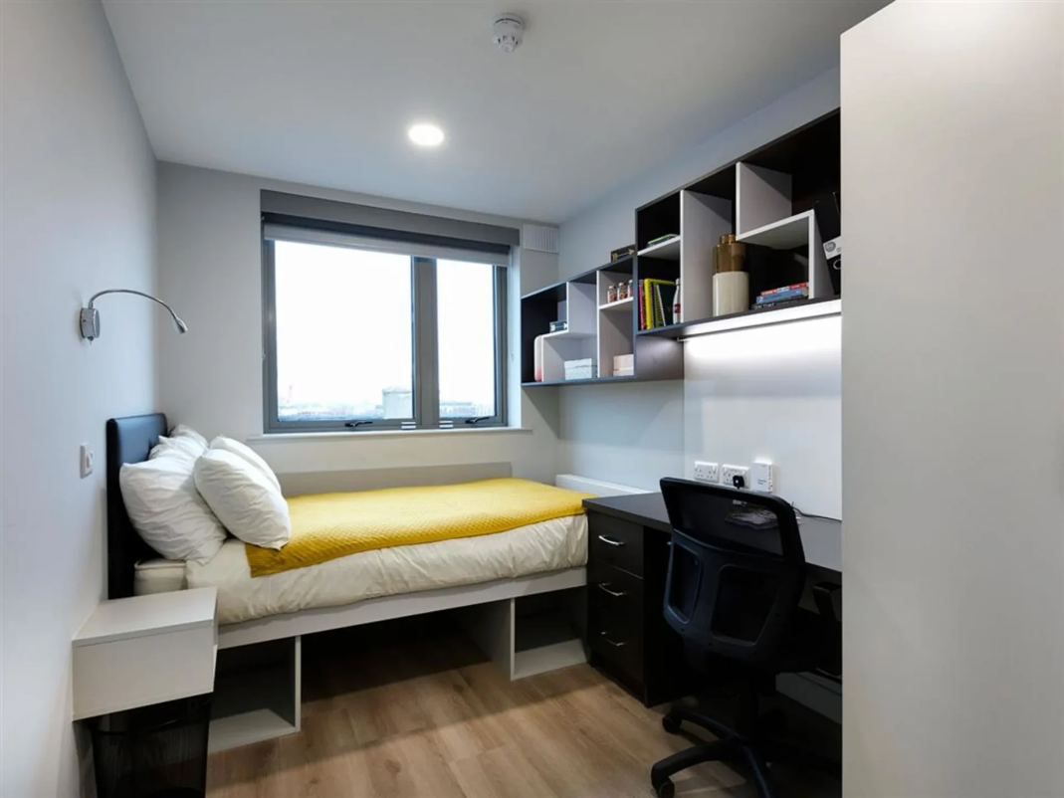
Contents
Oraganisation Name 1
Organisation Overview 3
Brief History Of The Company 3
Misson 3
Vision 3
Target Audience 3
Website Goals and Objectives 3
KPIs Website Traffic 3
Online Applications 4
User experience 4
Current Website Analysis • Strengths 4
Weakness No Online Application System 4
• Outdated Website 4
Areas for Improvement based on the weaknesess No online Application System 4
Functionality Homepage 5
Contact page 5
Accomodation Services Page 5
Desired functionality 5
Layout and design 5
User experience considerations ` 5
Technical Requirements 5
Timeline and Milestone 6
Budget 6
References 6
References 7

Organisation Overview

Brief History Of The Company
EaziTown Residence was founded in 2010. We recognized the need for affordable and accessable accommodation for disadvantaged tertiary students it was established in Soweto, Johannesburg. EaziTown Residence expanded and open two new residences , EaziTown Residence and EaziTown Apartments accommodating over 1000 Tertiary Students.

Misson
Our mission is to provide safe, and accommodating environments for Students to succeed academically and ensuring that no Students are left homeless due to Finances

Vision
Our vision is to be the Leading Student accommodation provider in South Africa and transforming student lives through education.

Target Audience
Our Target Audience is Mainly disadvantaged Tertiary
Students enrolled in universities, colleges or any Higher educational instituition who face financial challenges.

Website Goals and Objectives
Encourage students to apply for accommodation using online applications offering useful information about the company.Improve engagement on social media by 50% within the first year of launching the new website. Increase website Traffic by 20% within few months of launching a new website.

KPIs Website Traffic
- Unique visitors
- Page views

Online Applications
- Number of online applications received
- Average time to apply
Social media engagement
- Followers and Engagement

User experience
- User satisfaction rate
- Feedback responses

Current Website Analysis • Strengths
The website provides useful information about the company’s accommodation services and the Location of the Residence.

Weakness No Online Application System
• The website does not have an online application system making it unreliable for potential Students to apply.

• Outdated Website
The website is outdated and does not have modern web design standards.

Areas for Improvement based on the weaknesess No online Application System
- Create an online application system that allows residents to easily apply for accommodation. Outdated Website
- Update the website’s design to make it modern and appealing.

Proposal Website Features and

Functionality Homepage
- EaziTown Residence is a social company dedicated to providing affordable accomodation for tertiary students About us
- EaziTown was founded in 2010 in 2014 weexpanded ouroperations

Contact page
• mabundavutlhari41@gmail.com, 011 586 1314 Johannesburg

Accomodation Services Page
• Single bedrooms R2000, Sharing bedrooms
R1500, WI-FI,

Desired functionality
• Ensure the website is optimized for various devices

Design and User Experience Color Scheme:
A calming and welcoming color scheme shades of blue and green

Typography:
Modern sans-serif font

Layout and design
- High quality images of the residence
- A header section consisting the logo , navigation,menu and search bar.

User experience considerations `
- A clear main navigation menu
- Clear and actionable CTA’s to encourage users to engage with the website

Technical Requirements
Web server : Apache or Nginux
Operating System: Linux
Storage: Minimum 5GB of storage space
Uptime: 99.9% uptime guarantee\
Domain name: (link unavailable)

Timeline and Milestone
- Week 1-2: Project Planning
- Week 3-4: Design
- Week 5-8: Front-end development
- Week 13-14: Testing Quality assurance
- Week 15: Launch

Budget
The budget is estimated at R50000-R60000 per year

References
Google, 2025.
https://www.google.com/imgres?imgurl=https%3A%2F%2Fdublin.ie%2Fwpcontent%2Fuploads%2F4.5.1-studentaccommodation1_664x400.jpg&tbnid=l2XDXD6Wyp2hMM&vet=10CBgQxiAoCmoXChMIm JXovPC5jAMVAAAAAB0AAAAAEAc..i&imgrefurl=https%3A%2F%2Fdublin.ie%2Fstudy%2Fs tudent-l . [Online]
Available at: https://www.google.com/imgres?imgurl=https%3A%2F%2Fdublin.ie%2Fwpcontent%2Fuploads%2F4.5.1-studentaccommodation1_664x400.jpg&tbnid=l2XDXD6Wyp2hMM&vet=10CBgQxiAoCmoXChMIm JXovPC5jAMVAAAAAB0AAAAAEAc..i&imgrefurl=https%3A%2F%2Fdublin.ie%2Fstudy%2Fs tudent-li

[Accessed 2 April 2025].

(QS, 2020)

References
QS, 2020. Why Student Accommodation Should be a Priority for Your University in 2020. [Online]
Available at: https://www.google.com/url?sa=i&url=https%3A%2F%2Fwww.qs.com%2Fwhy-student-accommodation-should-be-a-priority-for-your-university-in-2020%2F&psig=AOvVaw2ttdQk4n6M0Q-am9inacY9&ust=1743846671681000&source=images&cd=vfe&opi=89978449&ved=0CBQQjRxqFwoTCIDz2J6N
[Accessed 4 April 2025].

References

